**I depend in my analysis (Story) for this data on 3 factors (time, customer, stock code)**

1. **Time**

As a business analyst I want to know to the income earned per period , this period can be a year , month , day or hour.

I chose to do this time analysis for month and hour because after viewing the data, I noticed that some months have so high revenue where others not and come hours in the day have so many invoices.

* 1. **Query 1**: ordering the 13 months in the data depending on the **sales revenue** from each one then calculating the change in the revenue from the previous month and the percent for this change.

The output for this query shows that:

* **Nov 2011** is the **first** month in terms of sales revenue
* **Jan 2011** is the **last** month in terms of sales revenue

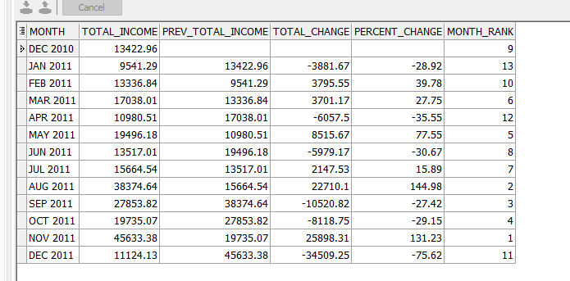

* 1. **Query 2:**

depending on number of orders in each hour and total income from each hour categorizing the working hours into **5 categories ( 'Platinum Hour', 'Diamond Hour', 'Gold Hour', 'Silver Hour', 'Bronze Hour')**

by this analysis we can know what are the rush hours in our business so we can take care more about the customer service

I depend on this analysis on an assumption that categorizing the working hours depends on the money earned from this hour and number of invoices in this hour

This analysis shows me that :

* The middle of each day is the **most** beneficial time for the business from **( 12 PM – 3 PM)**
* **(7 AM – 8 AM ) and 8 PM** are the **least** hours

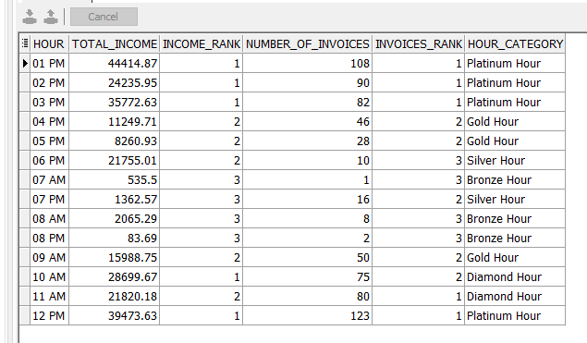

1. **Customer**

**a) Query 3**

In this query I wanted to study the relation between the total income and the customers

I categorize the customers into two categories depending on the sales revenue from them , So the first 20 % Group represents first 20 % of the customers who give the business the most revenue , last 80% Group represents the rest of customers

this analysis show us that:

* **the first group give 73% of the total sales**
* **the last group give 27% of the total sales**

in this analysis I provides the number of customers, total sales and number of invoices for each group .

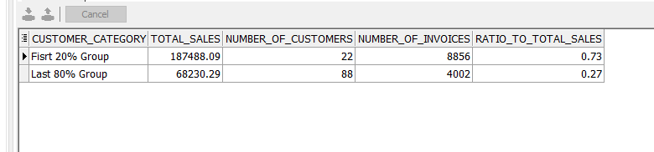

**b) Query 4**

I studied each customer alone by calculating the total sales from each customer and the consecutive days ( the difference between the date of the last order minus the date of the first order) and number of invoices for each one then the calculated the correlation between total of sales and the number of invoices and number

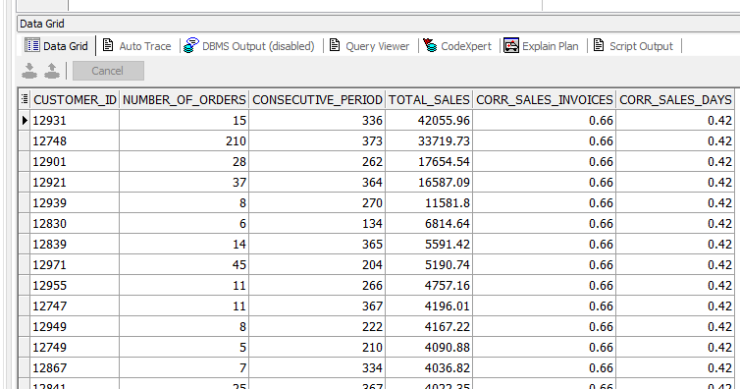

the output shows that

* there is a **good correlation between the sales and number of invoices**
* there is a **moderate correlation between the sales and consecutive days**

1. **Stock Code**

**a) Query 5**

I wanted here to give the stock code some analysis so I calculated number of invoices, total quantity sold and the total sales gained for each stock

then I ranked the stocks depending on two bases (sales ,invoices )

then calculating the correlation between the total sales and both the number of invoices and total quantity

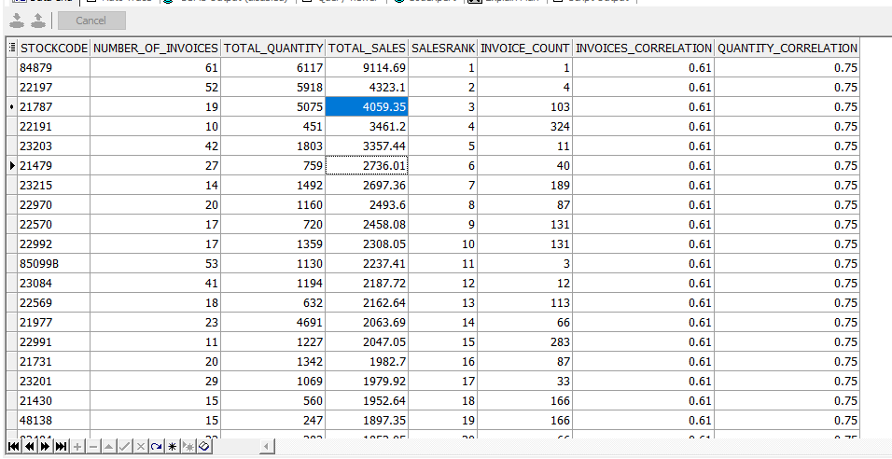

the output shows that

* there is a **good correlation between the sales and number of invoices**
* there is **a strong correlation between the sales and quantity**